**CAREER TRAJECTORIES DATASET ANALYSIS**

**SALARY & EXPERIENCE ACROSS GLOBAL INDUSTRIES**

CONTEXT:

**OBJECTIVE:** The primary aim of ‘salary and experience dataset across global industries’ is to perform analysis to understand career trajectories, salary trends, and compensation structures across various industries, examining the impact of experience, education, gender, and location on salaries and overall career growth.

**SCOPE:** The analysis covers salary-experience dataset focused within ,

* Salary distributions across industries, job titles, and experience levels.
* Gender based salary disparities.
* Correlation between education and salary.
* Impact of additional compensation.
* Country, State, City differences in salary trends.

**AUDIENCE:** Persons like- Job seekers looking for salary benchmarks, HR professionals and recruiters for market compensation analysis, Companies seeking insights into fair compensation structures, Researchers & Economists Study the impact of education and experience on earnings.

DATASET DESCRIPTION

**DATA COLLECTION:** The dataset comprises, 28104 records of salary-experience details including, Age range, gender, location(country, State, City), Work related details on Industry, job title, overall experience and field experience, pay information like Annual salary, additional monetary compensation, Highest level of education attained.

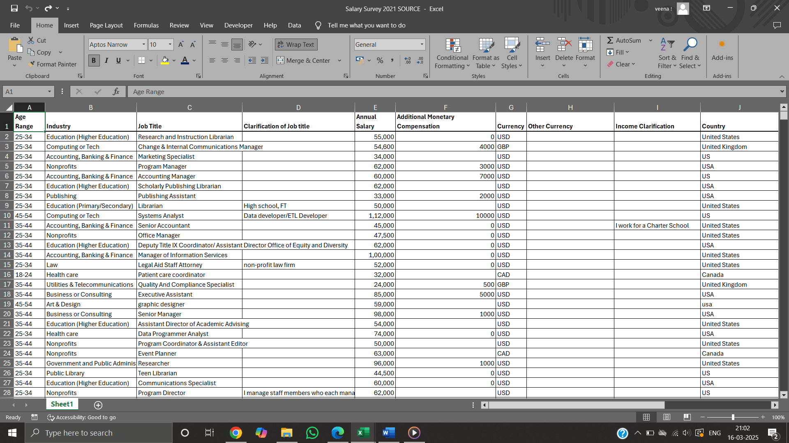

**DATA CLEANING:** To initiate with, the dataset is formatted by freezing first row, each column is formatted accordingly like annual salary, additional monetary compensation all in currency format remaining columns in general format. Cleaning each column by properly grouping relevant details and correcting spellings checking if any and different format for country state city are checked, correcting currency column comparing with other currency details. Removing blanks appropriately filling ‘unknown’, removing duplicates if present using data-remove duplicates. OUTLIERS ARE REMOVED WITH PROPER ANALYSIS AND UNWANTED COLUMNS LIKE CALARIFICATIONS ARE REMOVED.

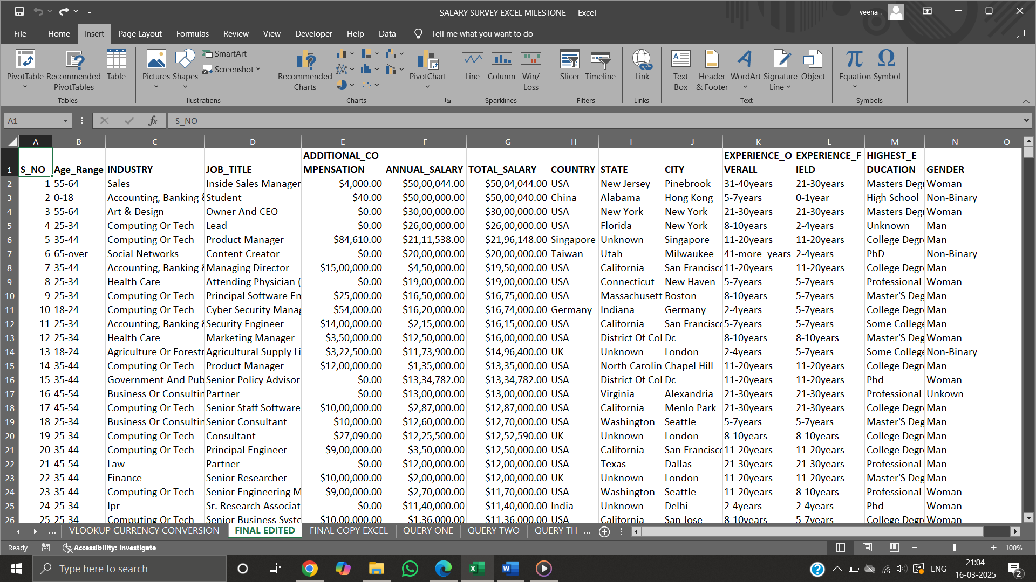

TECHNIQUES USED

In Dataset by using LOOKUP’S ,formulas and functions to perform operations like, AUD/NZD is separated with respect to country using FORMULA-IF CONDITION and any extra space in cell removed using function like TRIM and other tools to clean dataset. VLOOKUP is used to convert all currency to USD form by assigning corresponding conversion values.

**ANALYSIS PROCEDURE:** once the dataset is cleaned and all set to analyze, MYSQL workbench is opened to create database and table, designed a table structure to hold the dataset with appropriate column names and data types as in excel sheet to import. With the help of table import wizard MYSQL IMPORT TOOL, dataset from excel is imported into table-created. Entire data in worksheet is available as single table to perform query.

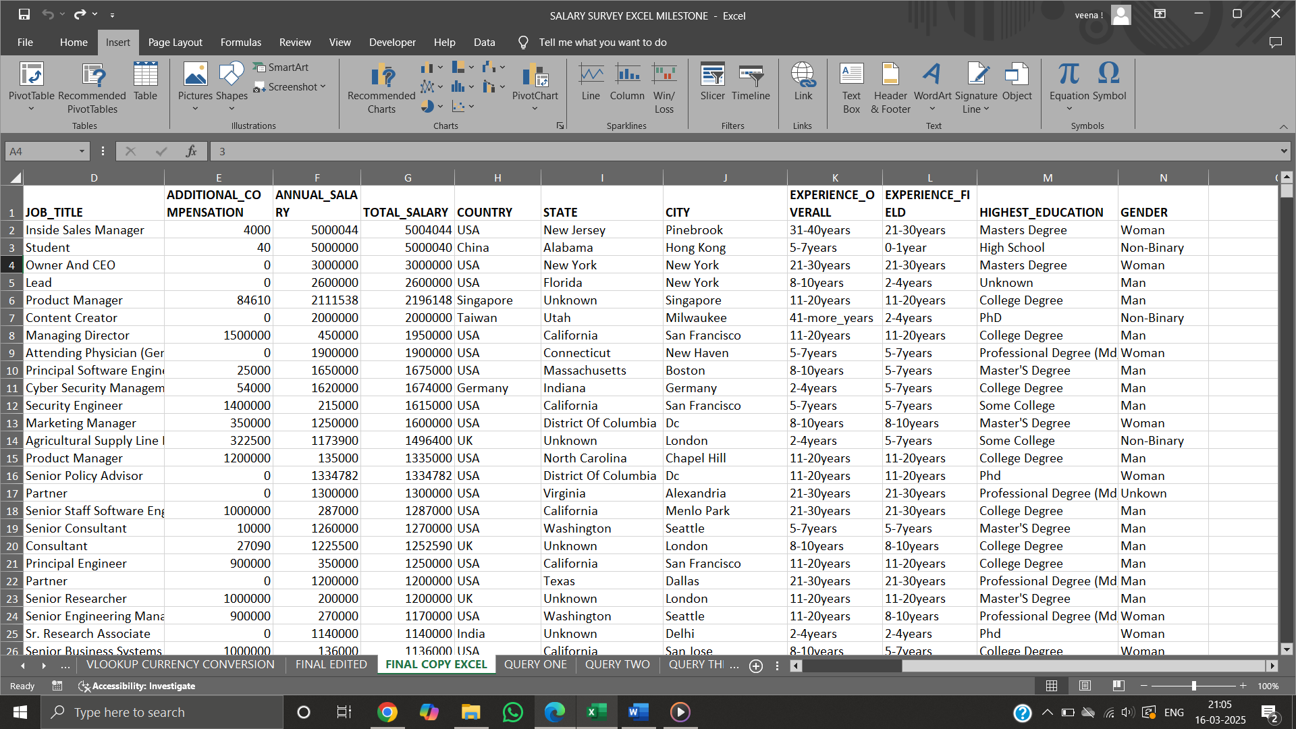

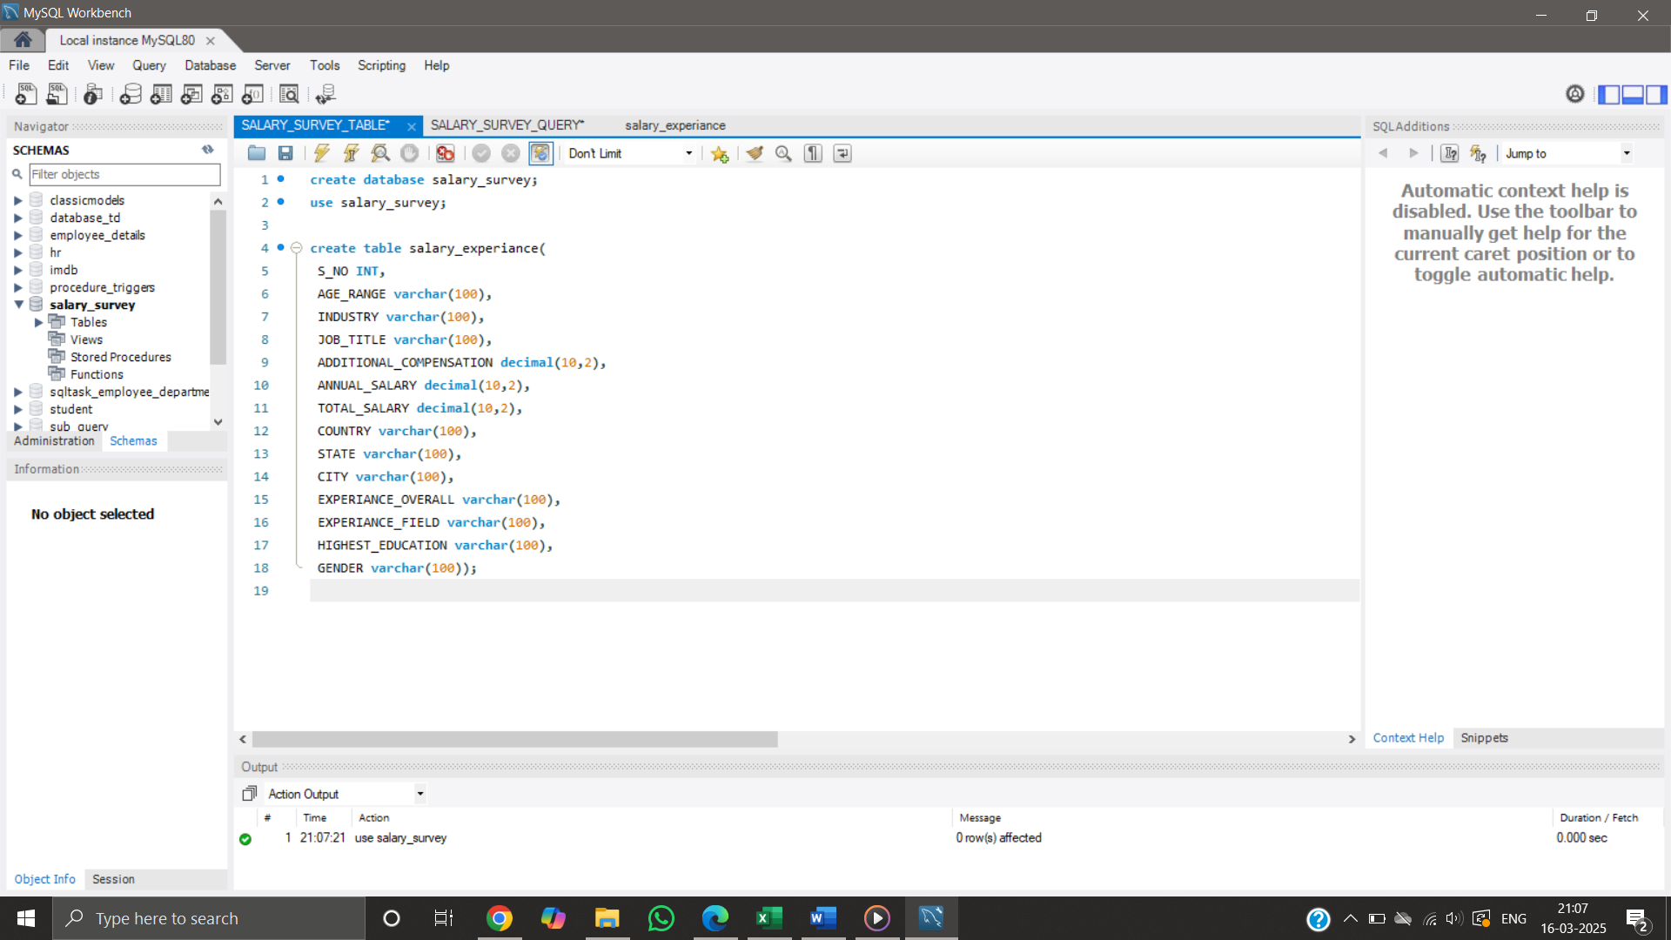

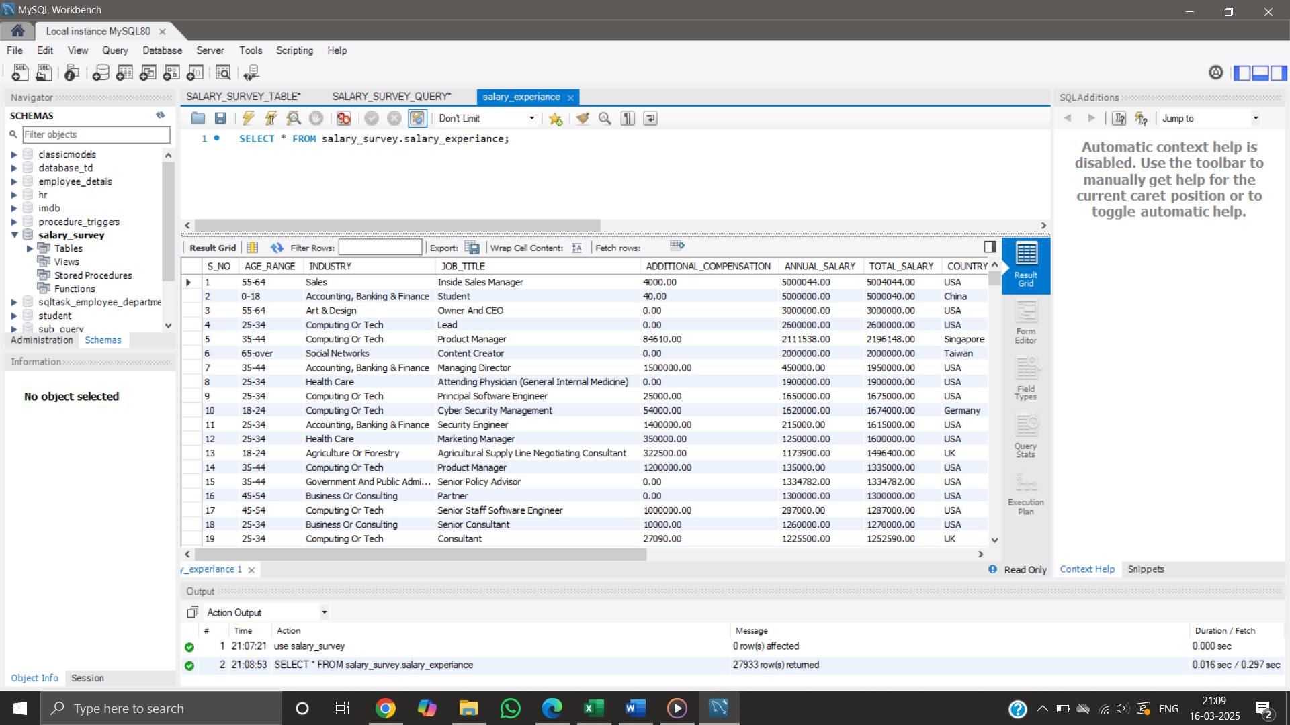

**QUERYING THE DATA REQUIRED FOR DASHBOARD CREATION.**

1. Compare the average salary within each industry, split by gender.

Shows average annual salaries segmented by industry and gender. Example: Women in "Government Relations" earn an average of $65,000. Helps analyse gender pay across different industries.

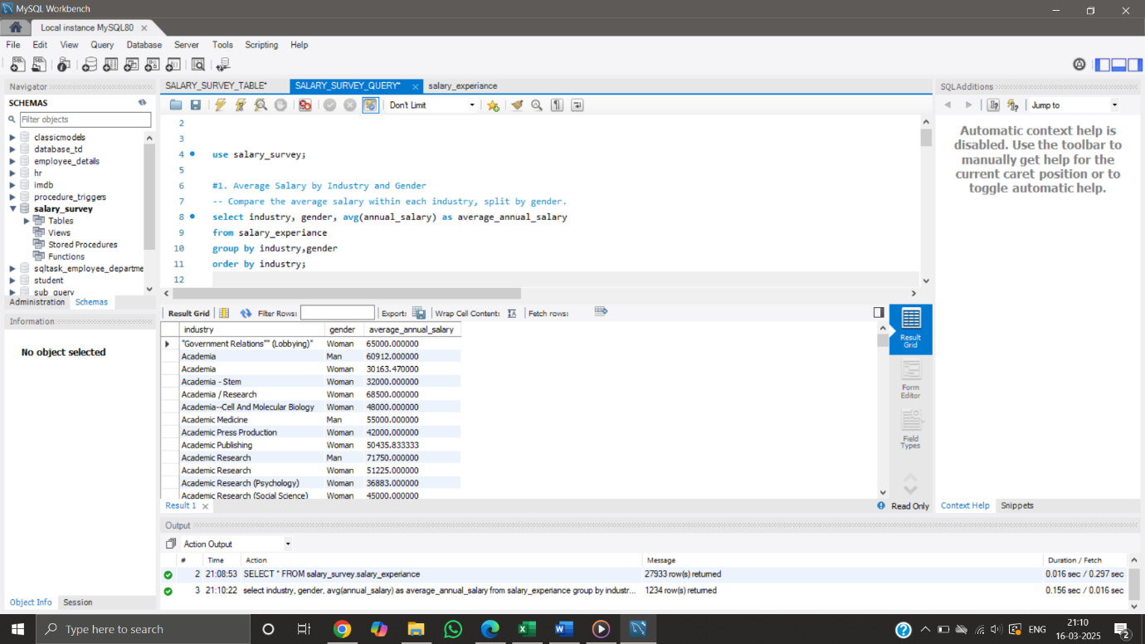

1. Find the total monetary compensation (base salary + additional monetary compensation) for each job title.

Aggregates total compensation (salary + additional pay) for various job titles. Example: Software Engineers collectively earn the highest total compensation. Useful for identifying high-paying job roles.

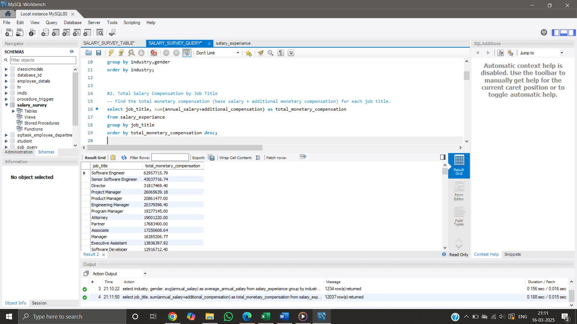

1. Find the salary distribution (average salary, minimum, and maximum) for different education levels.

Compares average, maximum, and minimum salaries based on education. Example: Master's degree holders earn an average of $4,000,022, while high school graduates earn significantly less. Highlights the impact of education on salary.

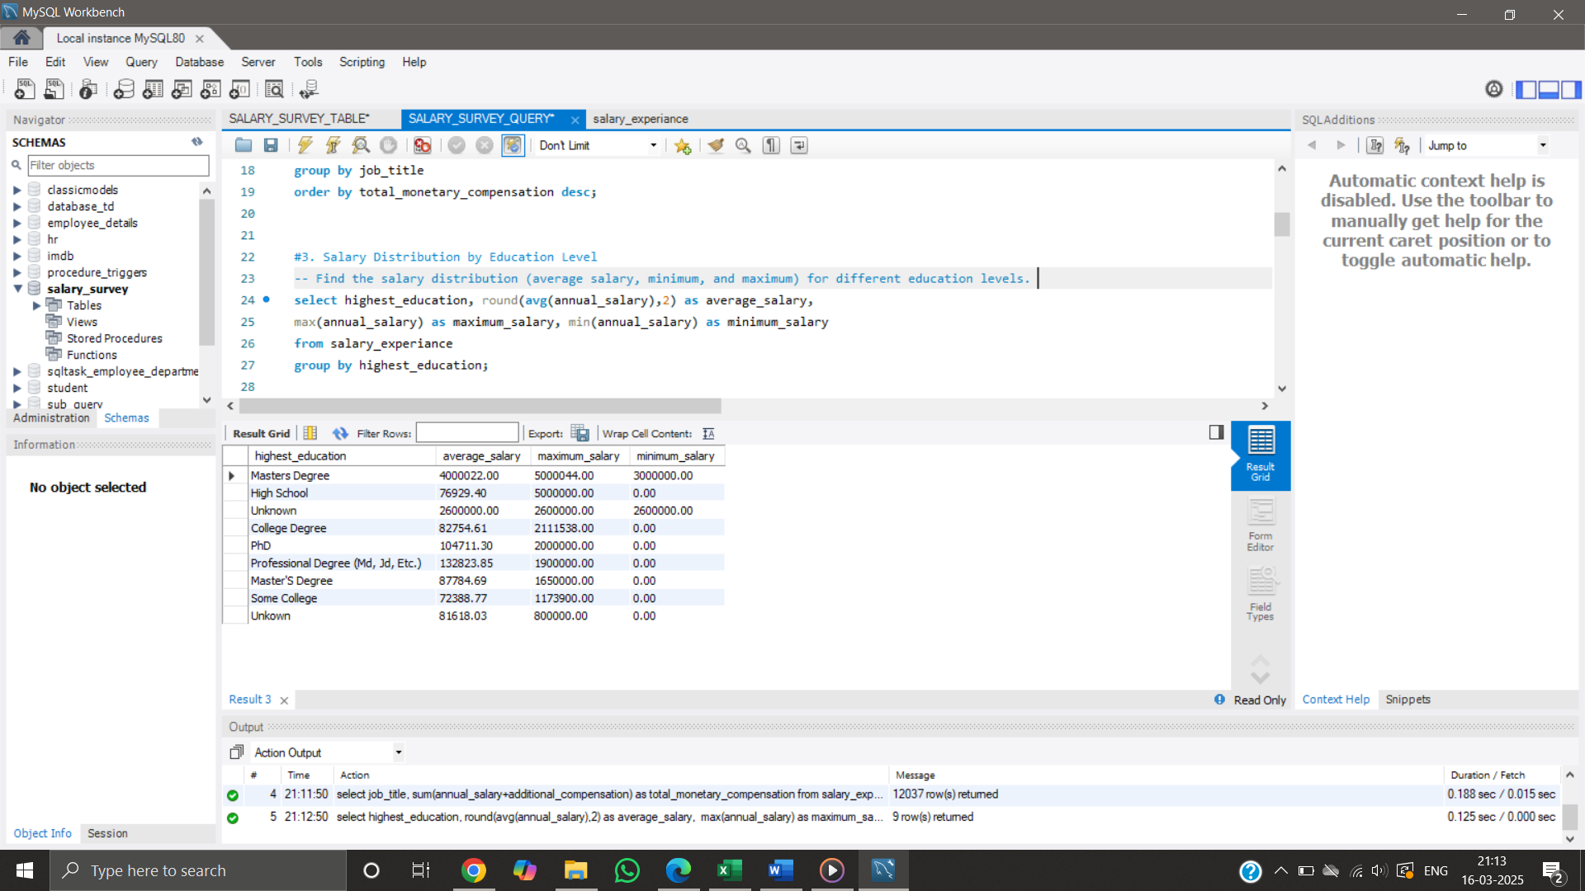

1. Determine how many employees are in each industry, broken down by years of professional experience.

Shows the number of employees in various industries segmented by experience. Example: The Computing/ Tech sector has the most employees with 11-20 years of experience. Useful for workforce distribution analysis.

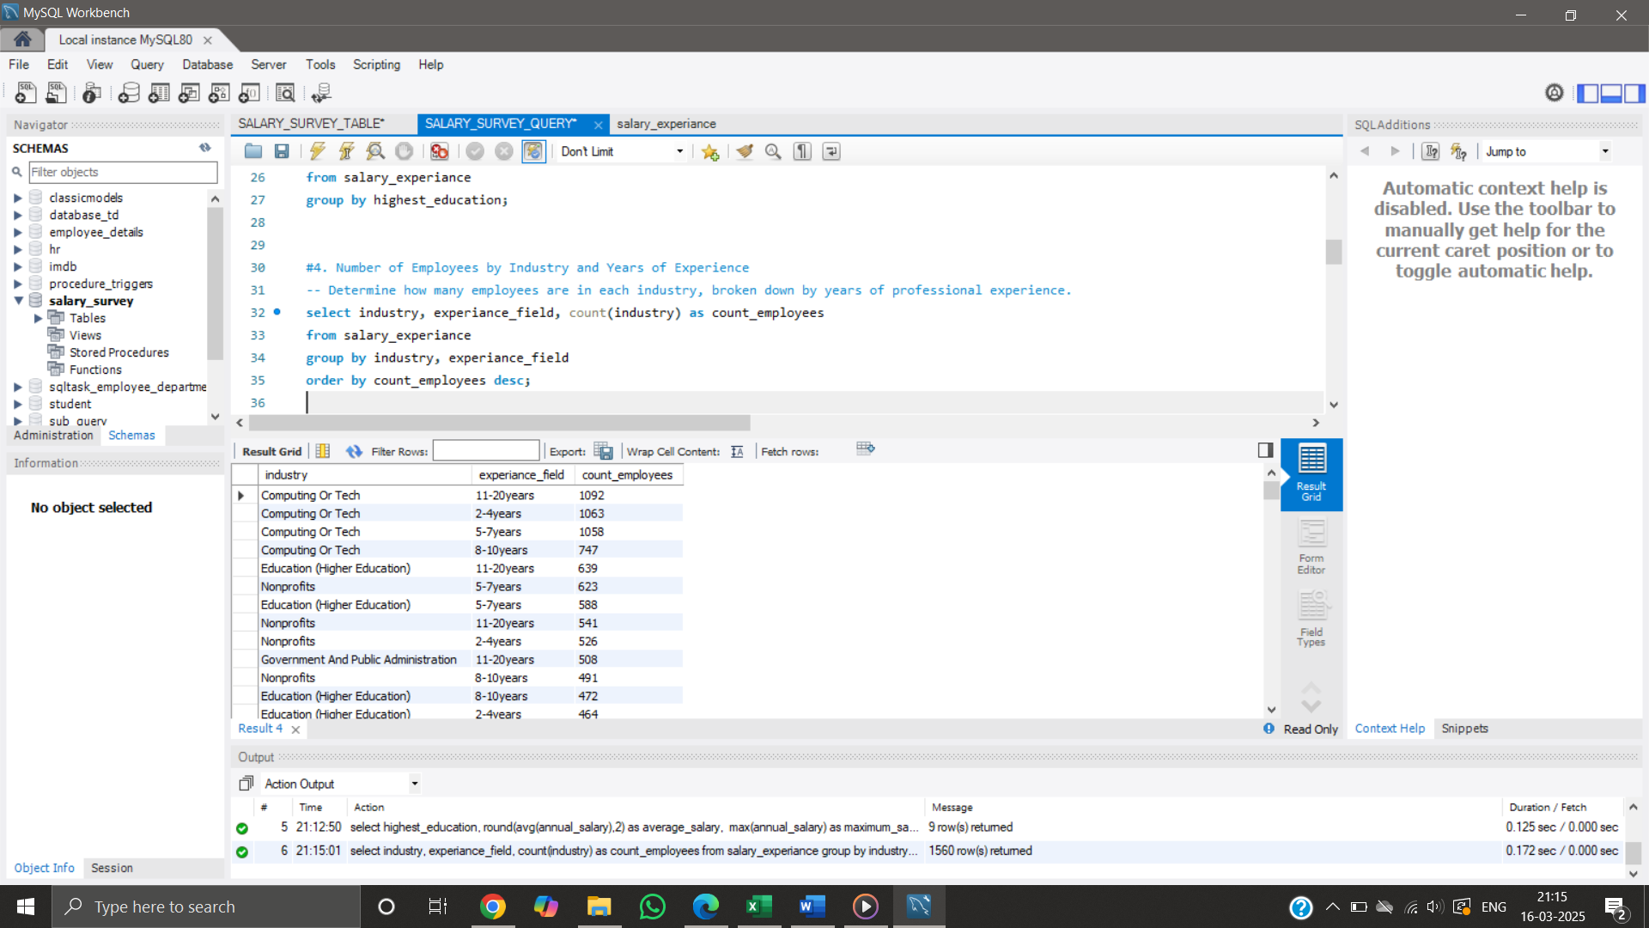

1. Calculate the median salary within different age ranges and genders.

Displays the median salary for different genders and age groups. Example: Non-binary individuals aged 18-24 have a median salary of $37,615.50. Useful for studying salary trends across different demographics.

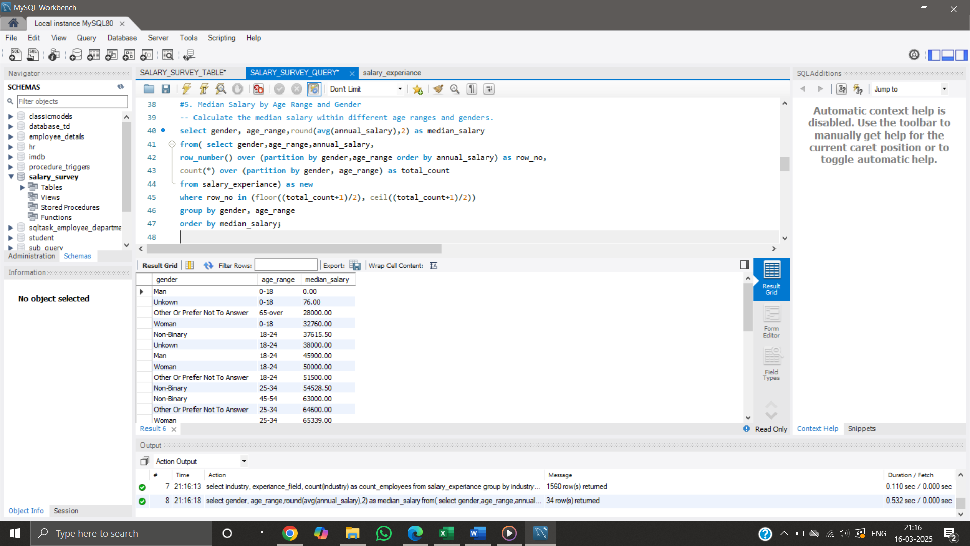

1. Find the highest-paying job titles in each country.

Lists the highest salary recorded for each country and job title. Example: IT Security Consultants in Australia earn up to $630,000. Useful for geographic salary comparisons.

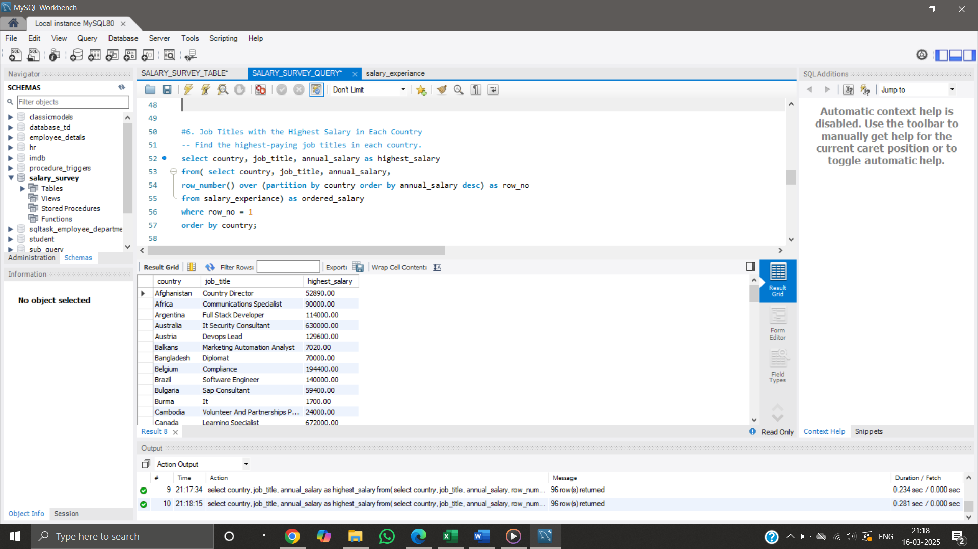

1. Calculate the average salary for each combination of city and industry.

Breaks down salary data based on industry and city. Example: The highest salaries in "Government Relations" are in New York City. Helps in location-based salary analysis.

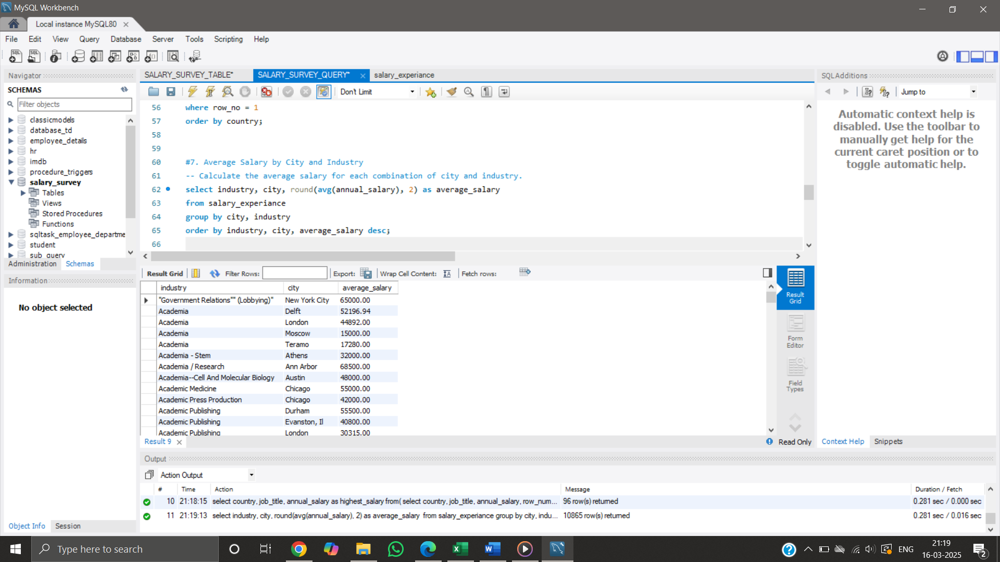

1. Find the percentage of employees within each gender who receive additional monetary compensation, such as bonuses or stock options.

Displays workforce distribution based on gender. Example: Women make up 73.52% of the employees, while men account for 22.89%. Useful for gender diversity analysis.

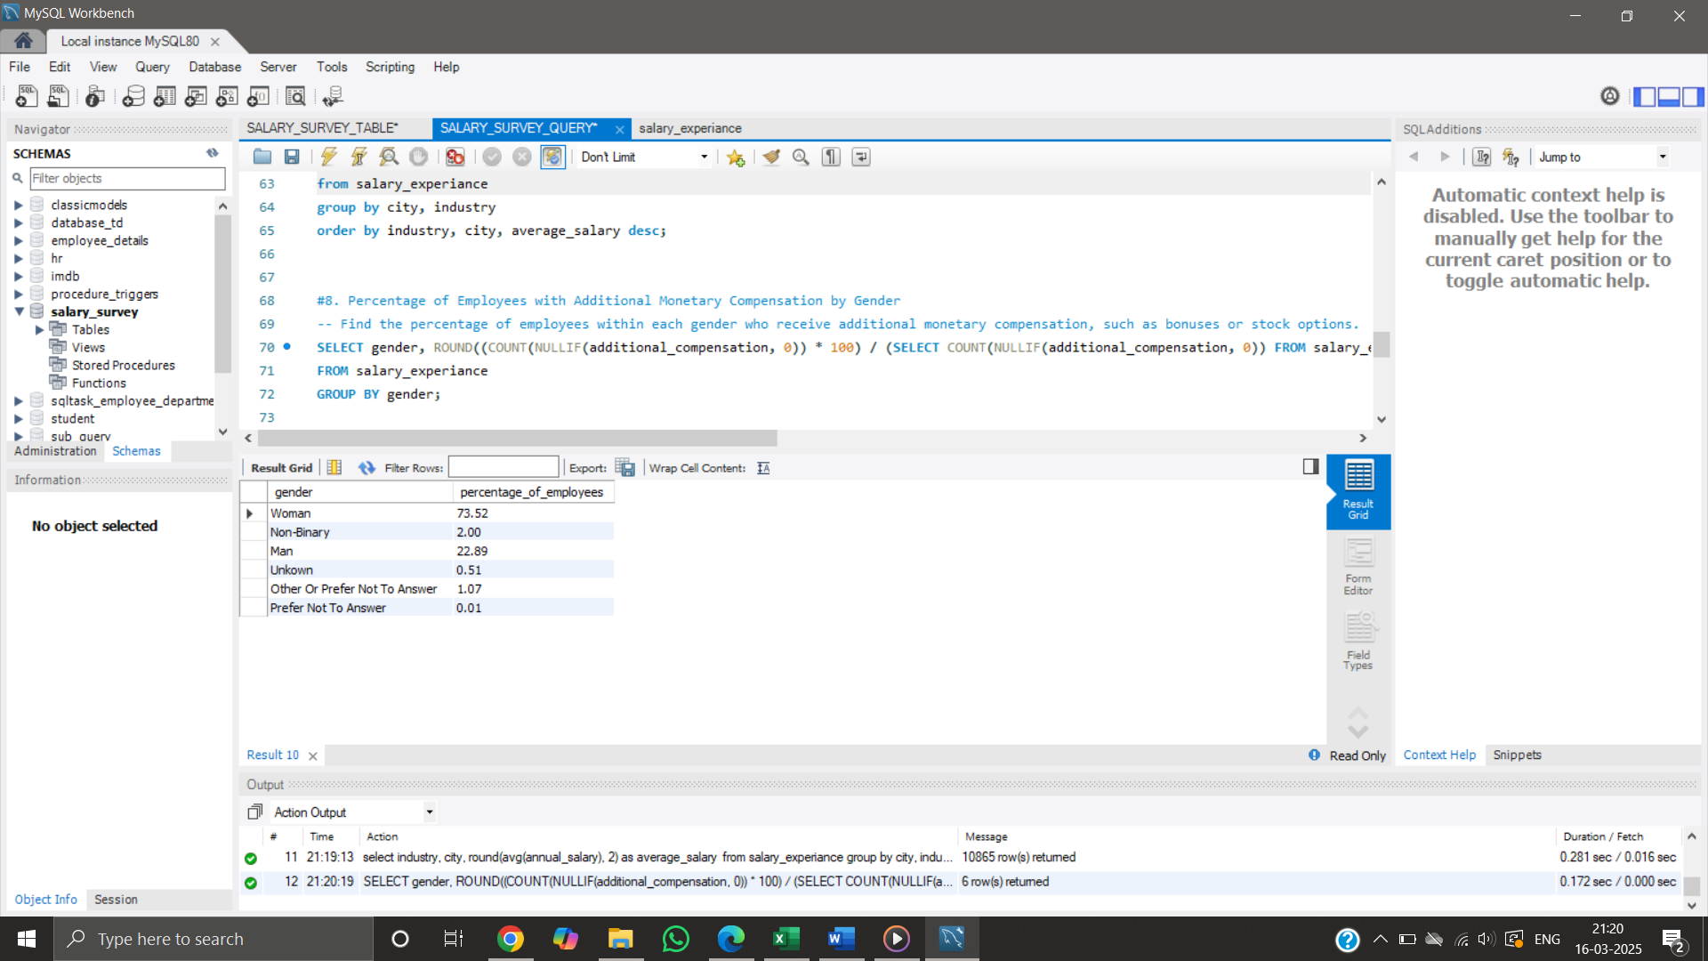

1. Determine the total compensation (salary + additional compensation) for each job title based on years of professional experience.

Aggregates total earnings based on job titles and experience. Example: Software Engineers with 2-4 years of experience collectively earn the highest total compensation. Helps identify career progression trends.

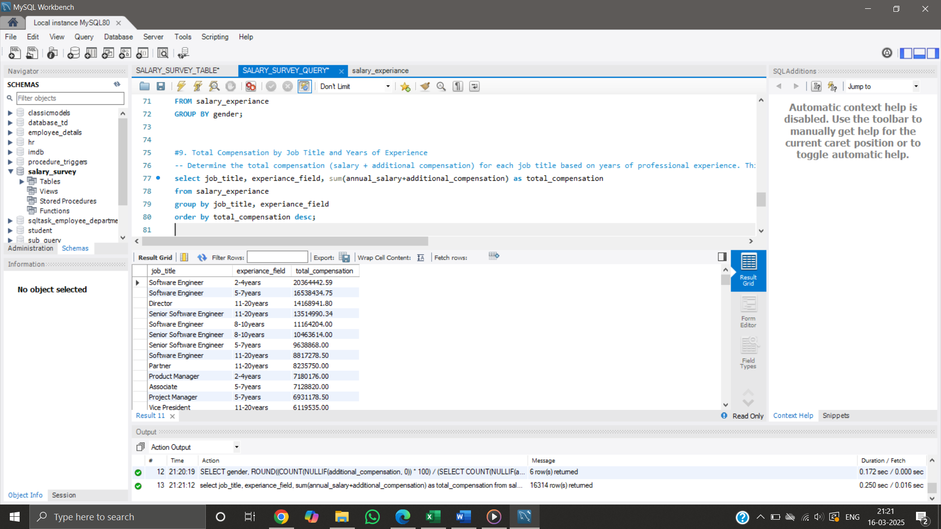

1. Understand how salary varies by industry, gender, and education level.

Examines salary variations across industry, gender, and education levels. Example: Women in Sales with a Master’s degree earn $5,000,044 on average. Useful for understanding the combined effect of education and industry on salary.

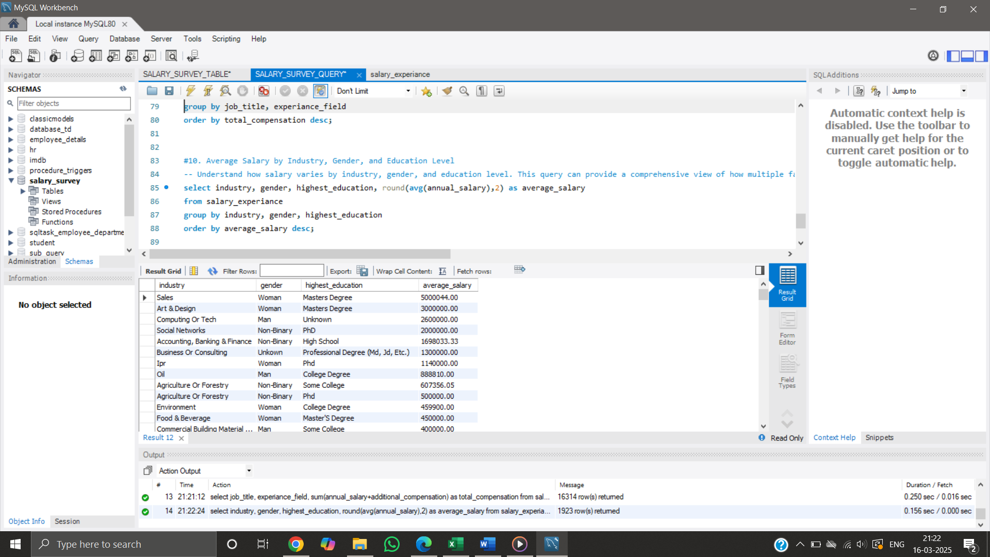

**Export Data from MYSQL:**

After running each SQL query, export the result to a CSV file. EXPORTED FILE IS NOW imported into Excel, Open Excel TO create a new workbook. Import the respective CSV file into each sheet.

* Average salary within each industry, split by gender.

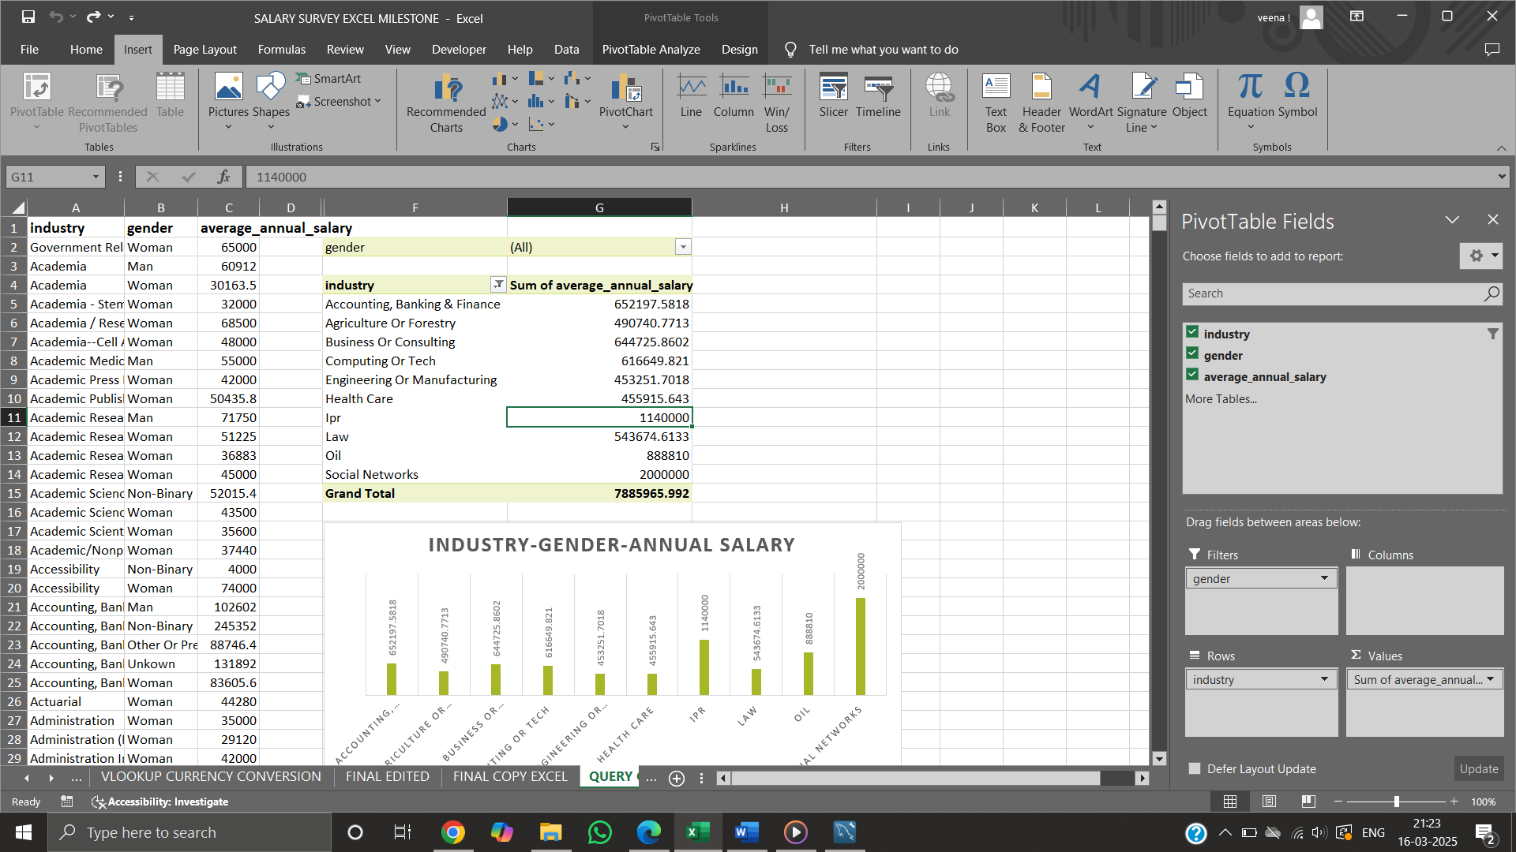

* Total monetary compensation for each job title.

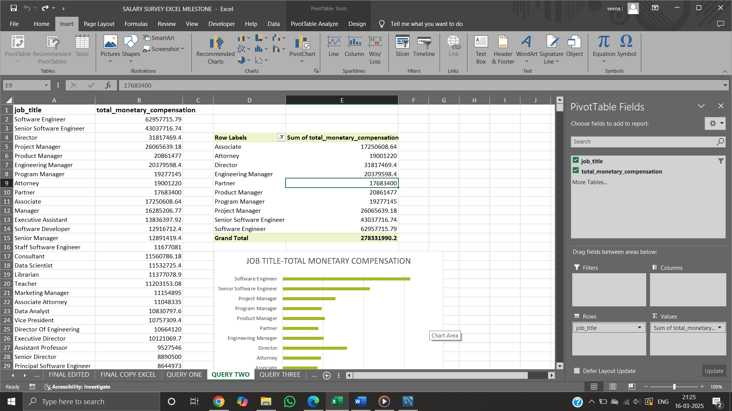

* Salary distribution (average salary, minimum, and maximum) for different education levels.

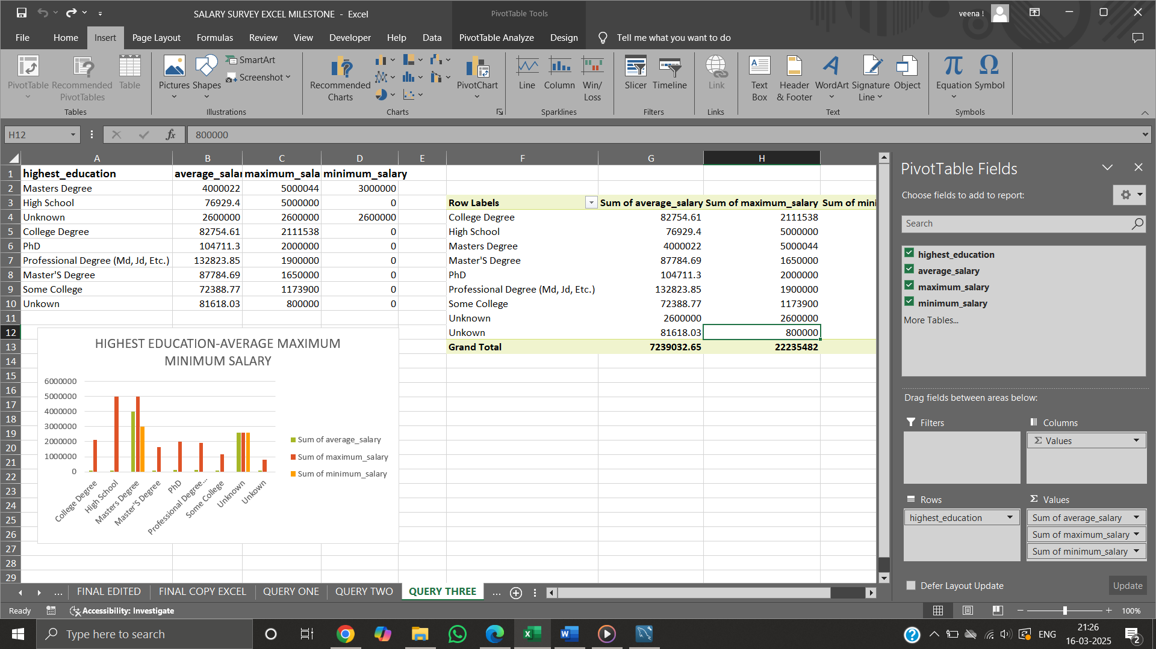

* Employees are in each industry, broken down by years of professional experience.

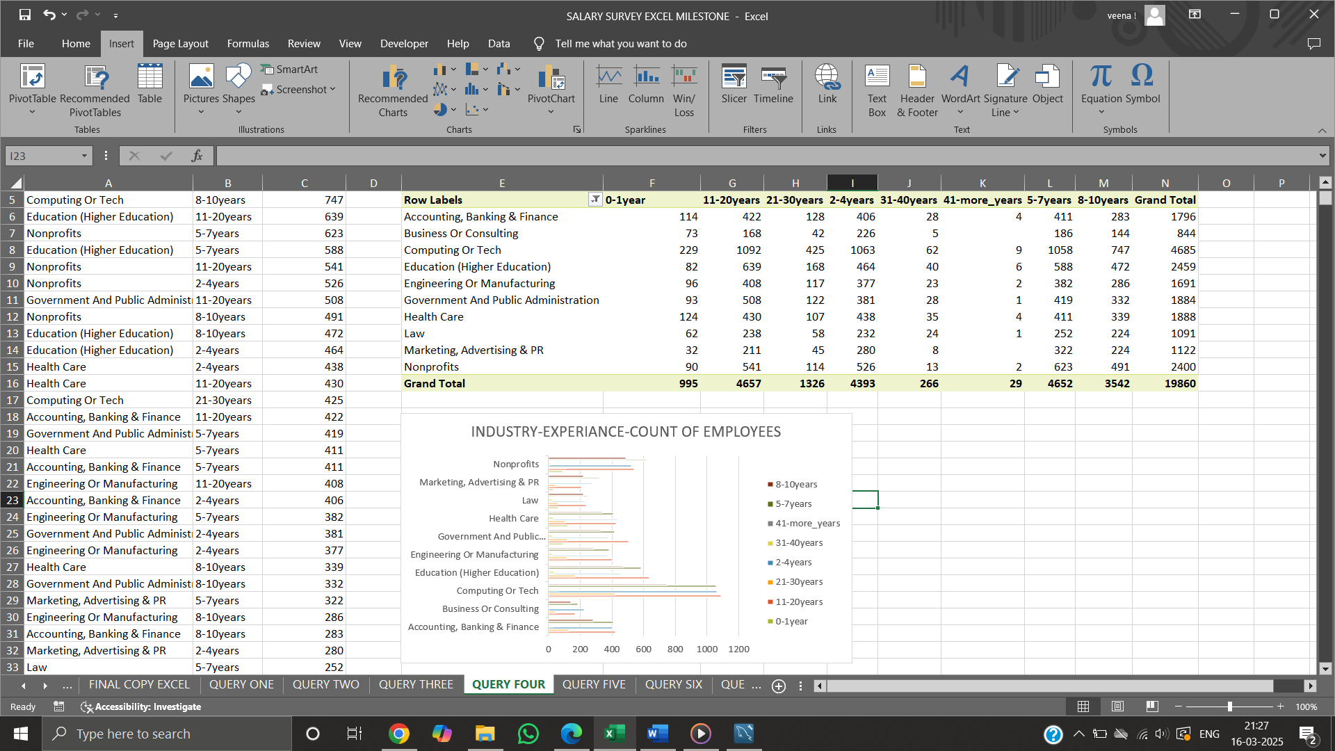

* Median salary within different age ranges and genders.

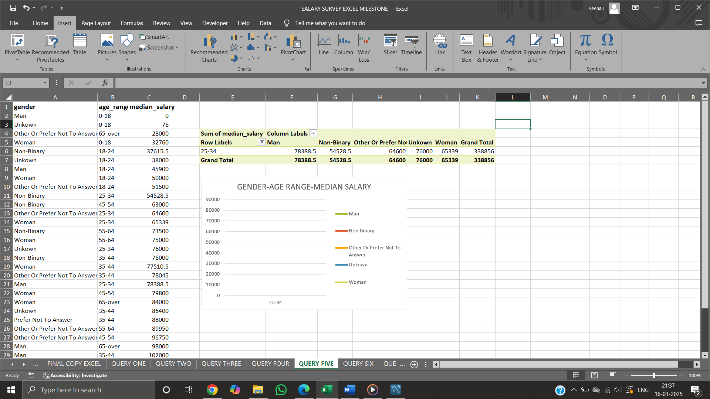

* highest-paying job titles in each country.

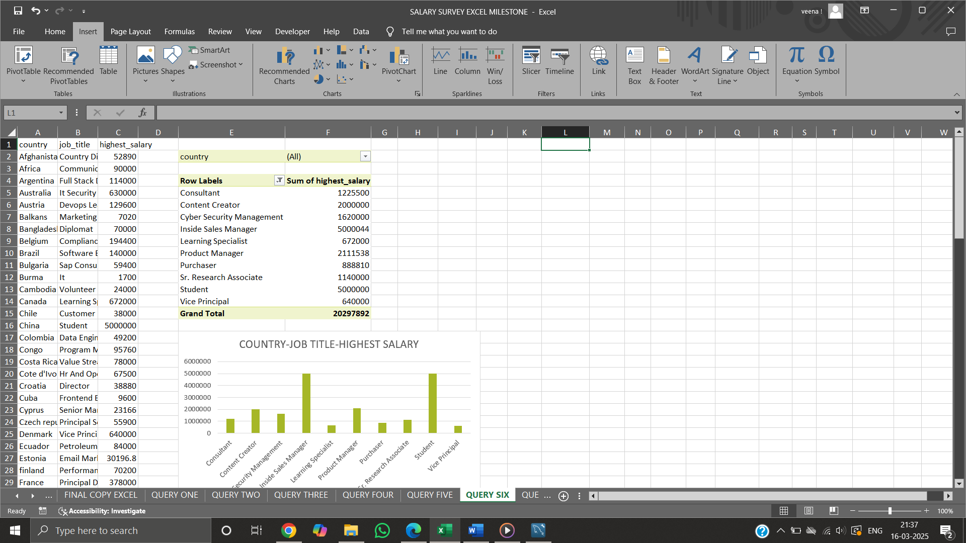

* Average salary for each combination of city and industry.

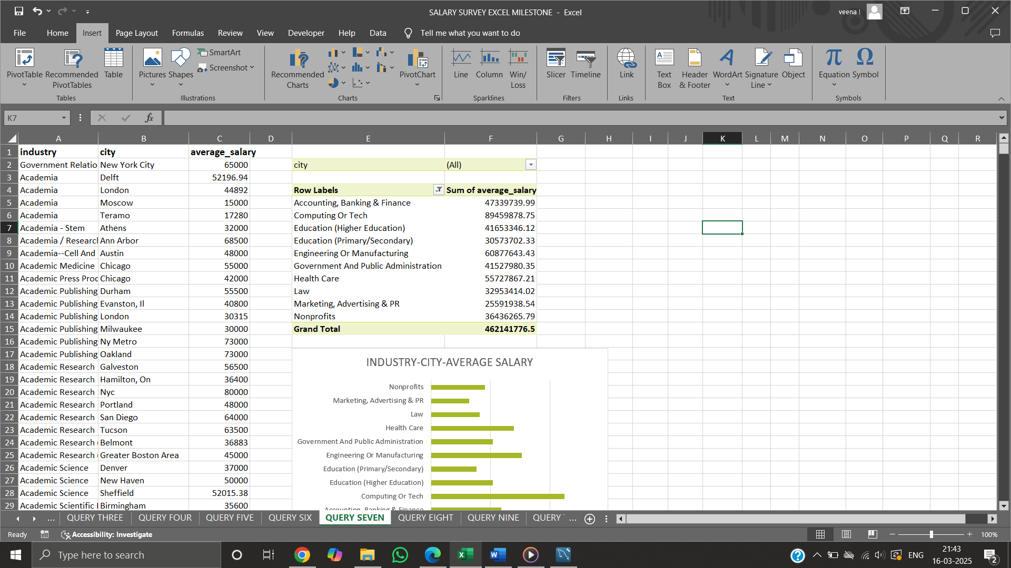

* Percentage of employees within each gender who receive additional monetary compensation, such as bonuses or stock options.

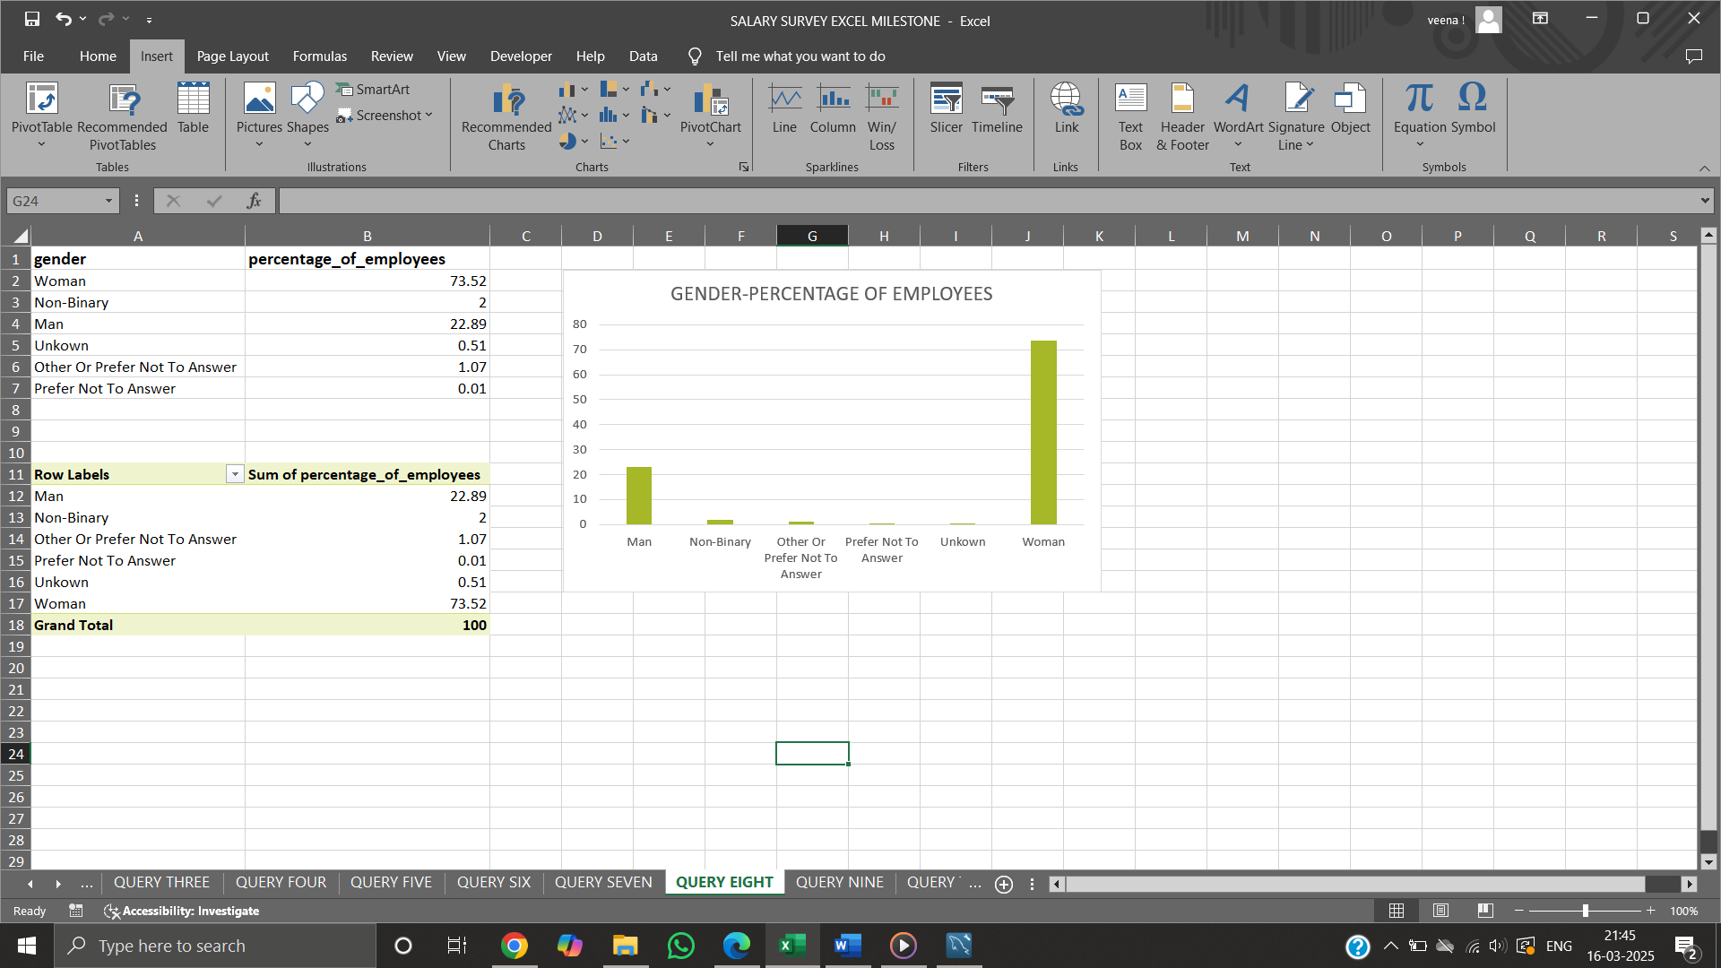

* Total compensation (salary + additional compensation) for each job title based on years of professional experience.

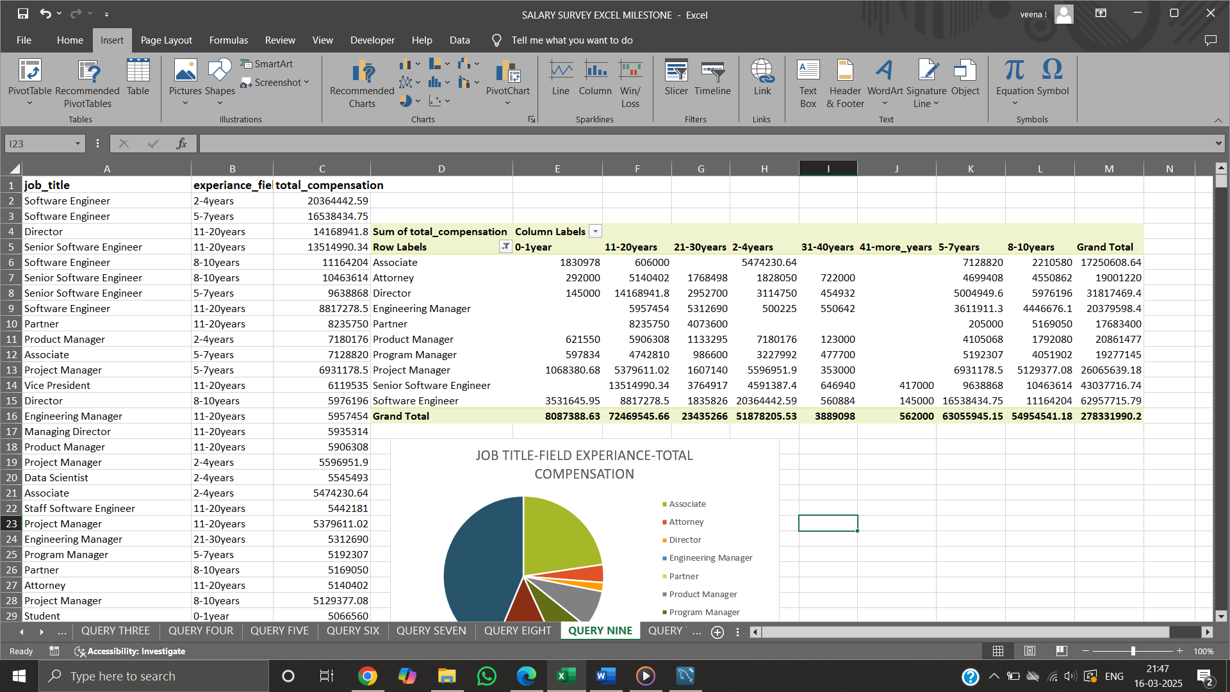

* Salary varies by industry, gender, and education level.

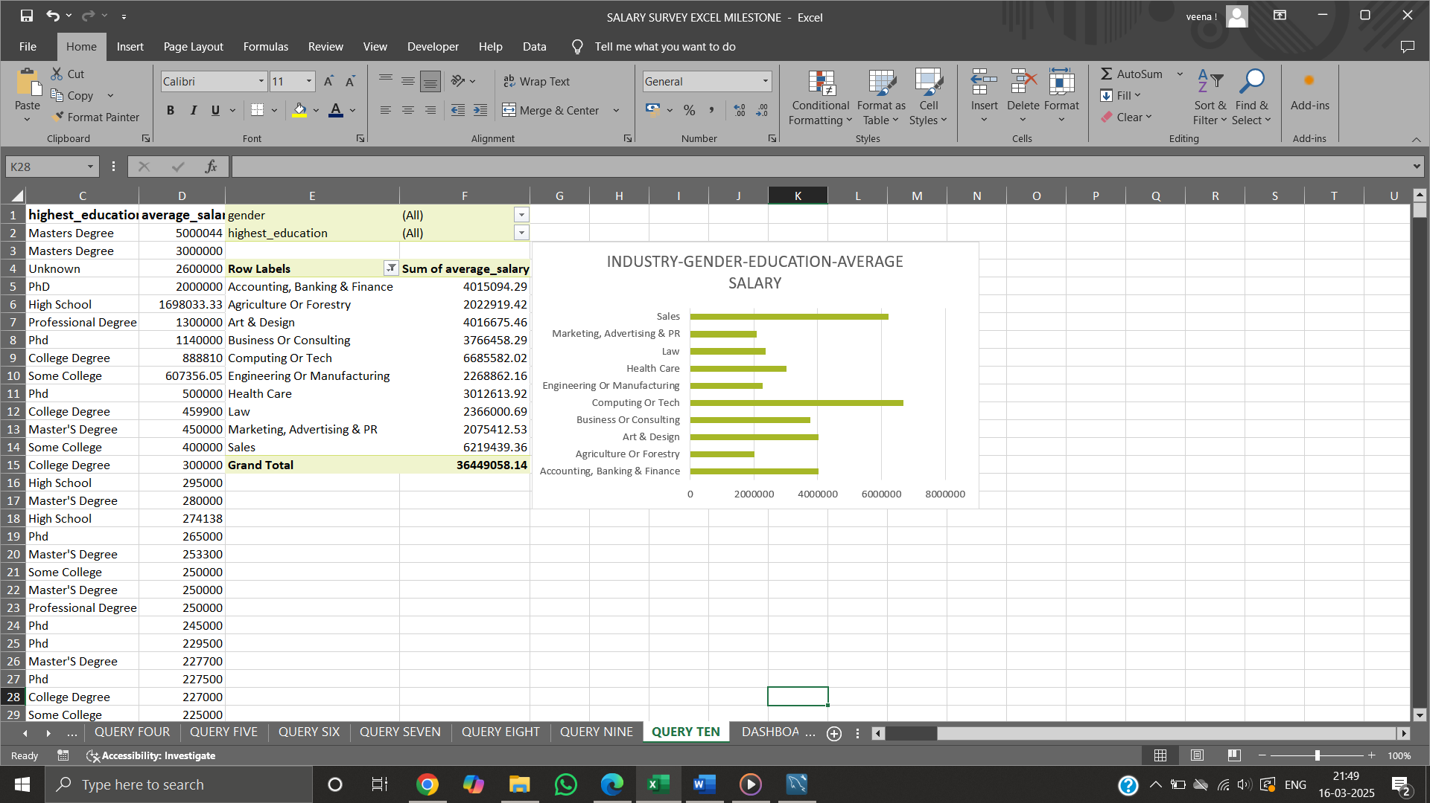

**PIVOT TABLE AND CHART:**

Pivot tables in excel used to summarize large dataset in simple tabular form making analysis easier to access, explore and present data. Pictorial representation of pivot table is pivot chart. In excel, create pivot tables from the data in each sheet to summarize and analyse the key metrics. By using respectful fields for rows, columns, values, and filters meaningful insights can be obtained from the data.

* Salary distribution by industry.

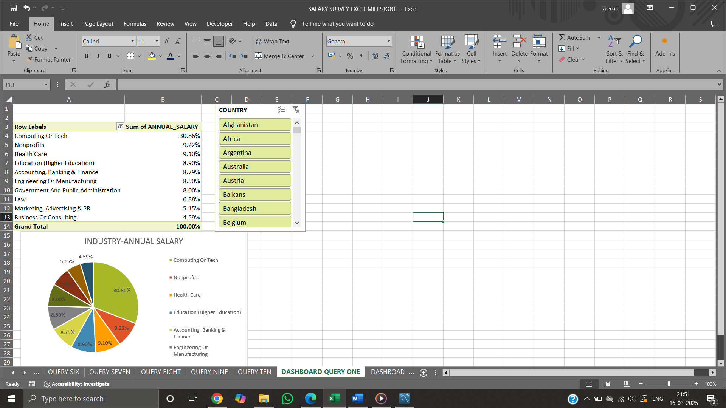

* Gender distribution across different job titles.

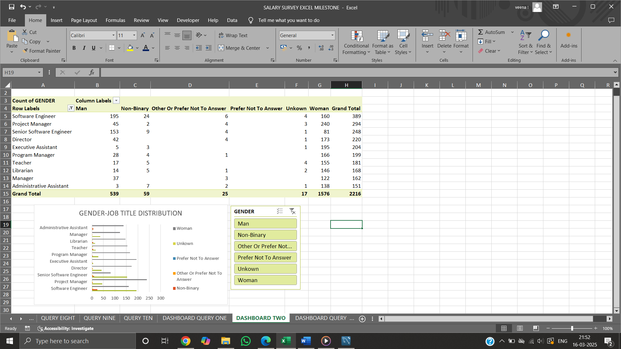

* Top-paying job titles.

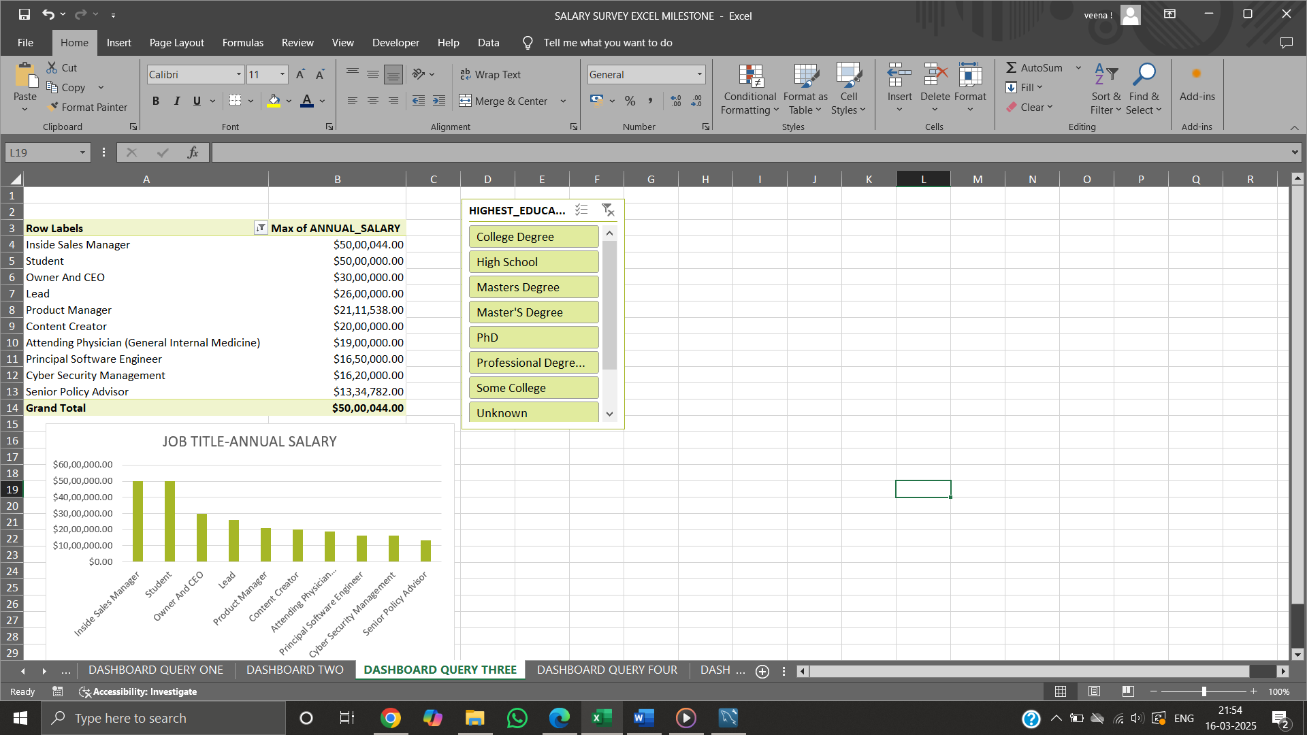

* Field experience to annual salary.

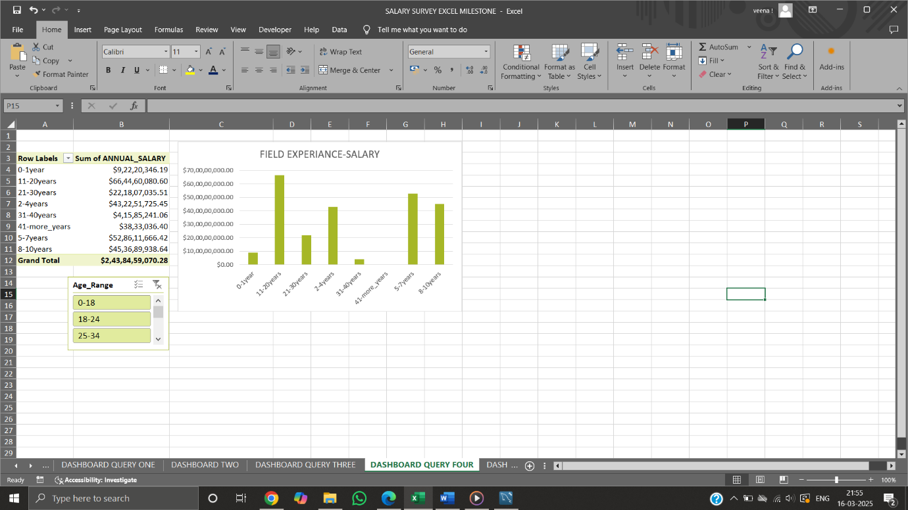

**KPI’S:**

A visual representation of key metrics, often using charts and tables, to quickly track and analyse business performance against defined goals. A KPI dashboard is a tool that helps you visualize and monitor the progress of your business towards specific objectives.

KEY PERFORMANCE INDICATORS,

* Sum of ANNUAL_SALARY
* Sum of ADDITIONAL_COMPENSATION
* Sum of TOTAL_SALARY
* Count of RECORDS

**DASHBOARD CREATION:**

A Dashboard is used to monitor, organise, analyse and update large dataset in real-time, by using visual filtering tools like slicers and KPI’s that makes it more interactive.

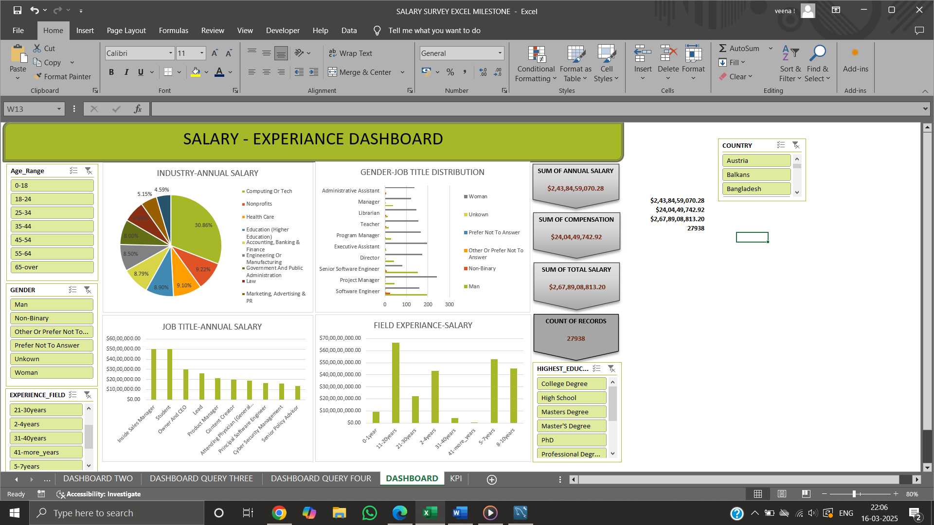

FINDINGS

**INSIGHTS:**

* Certain industries, such as tech and finance, offer higher median salaries compared to others like art and design.
* Professionals with over 10 years of experience tend to earn significantly higher salaries.
* Advanced degrees, particularly master's and PhDs, correlate with higher salaries.
* Salaries vary considerably by country and city, with tech hubs offering the highest compensation.
* Stock options and bonuses significantly boost overall earnings in certain sectors.
* Tech & Finance offer the highest salaries.
* Men earn more on average, even in female-dominated industries.
* Senior professionals (11-20 years) earn the most.
* Major cities (New York, London, Sydney) have the highest salaries.
* Developing countries see much lower pay for similar jobs.

**CONCLUSION:**

The analysis highlights clear trends in salary structures influenced by industry, experience, and education. It also sheds light on gender-based wage disparities and regional salary differences. Companies can use these insights to create more equitable and competitive salary structures.

**FUTURE RECOMMENDATIONS:**

* Promote upskilling and education initiatives to help professionals increase their earning potential.
* Further studies on salary negotiations and workplace policies affecting compensation.
* Region-specific compensation adjustments to account for cost-of-living differences.
* Initiatives to close gender wage gaps through policy and awareness programs.

THANK YOU

REPORTED BY,

VEENA SRI PM,

DATA ANALYTICS AND DATA SCIENCE,

RP-33.